MASCHERPA Audric ROB 3 2022 / 2023

**POLY-SNAKE**

**Weekly report n°19 from 04/04/23 :**

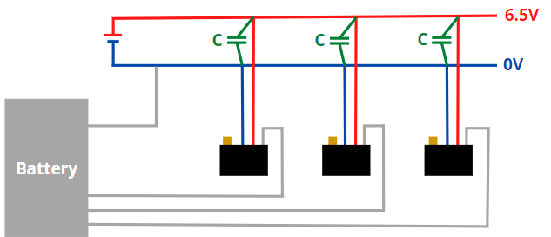During the next sessions I will be responsible for wiring the servomotors to the power supply shown in figure 19.1

Figure 19.1

So, first of all I took care of determining the necessary capacitors in order to avoid a voltage drop in the system. I used the following equation :

E = *C*(-)

With E the energy in J, C the capacitor in F and V1/V2 the voltage max and min from the voltage drop in V.

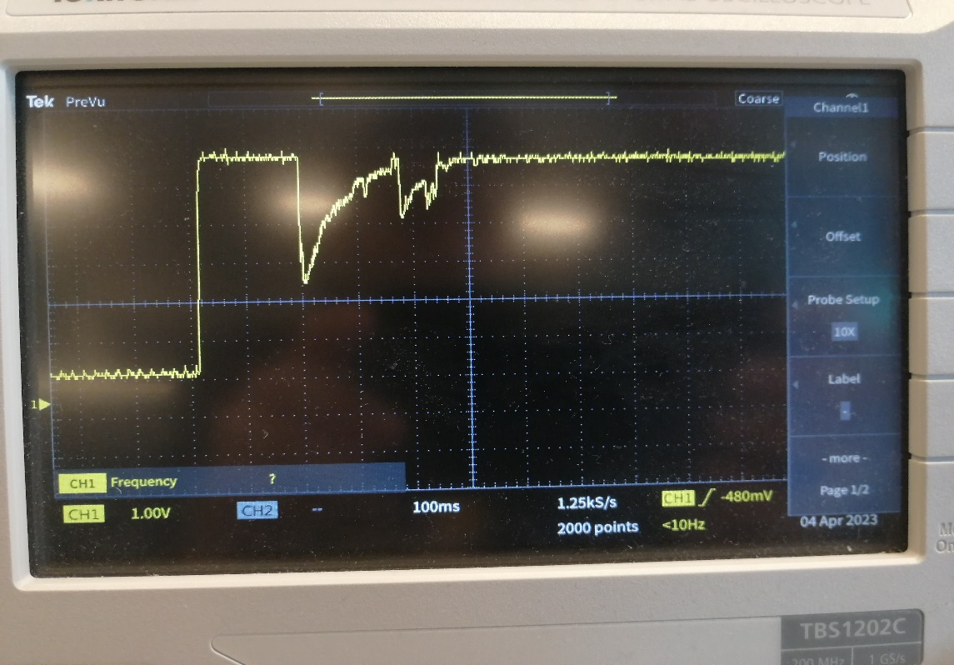To calculate each of the elements and determine C I used the curve in figure 19.2.1 made using the assembly 19.2.2 and 19.2.3.

Figure 19.2.1

2.4V

6.4V

**Δ**T=250ms

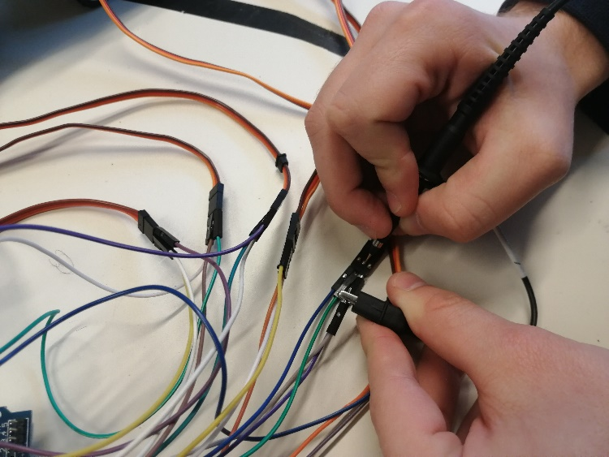

Figure 19.2.2

Figure 19.2.3

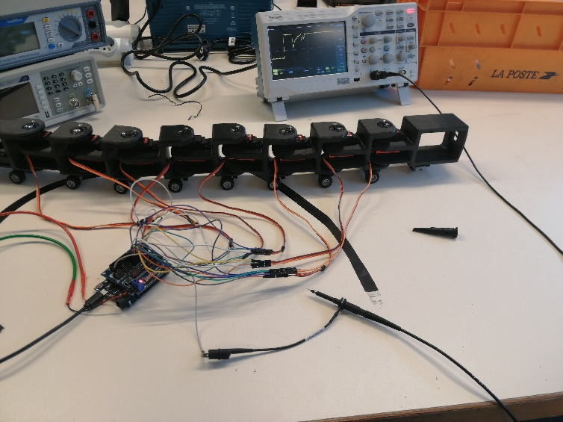

So, knowing that the power supply used to operate the servomotors is 6.4V and 2A then we can determine the power in W then by knowing Δt determine the energy E:

P = V*I

P = 6,4*2=12.8W

But, E=P*Δt

E=12.8*250.=3.2J

We can now determine the capacitor to use:

C=

C==0.18F

Although the calculations were well carried out and the result must be divided by 8 due to the 8 servomotors in the Polysnake which are in parallel, **2.2mF** per capacitor is an inconsistent value because it is much too large compared to the use that will to be made of it.

So, while waiting to understand where the error was made, we are going to use a 1000µF capacitor and check if the latter allows the voltage drops to be limited and change it if this is not the case.

Following this, I was able to start welding the servomotors to the power cables by adding connectors between each servomotor in order to be able to dismantle the snake once the cables are welded as

shown in figure 19.3.1 and 19.3.2.

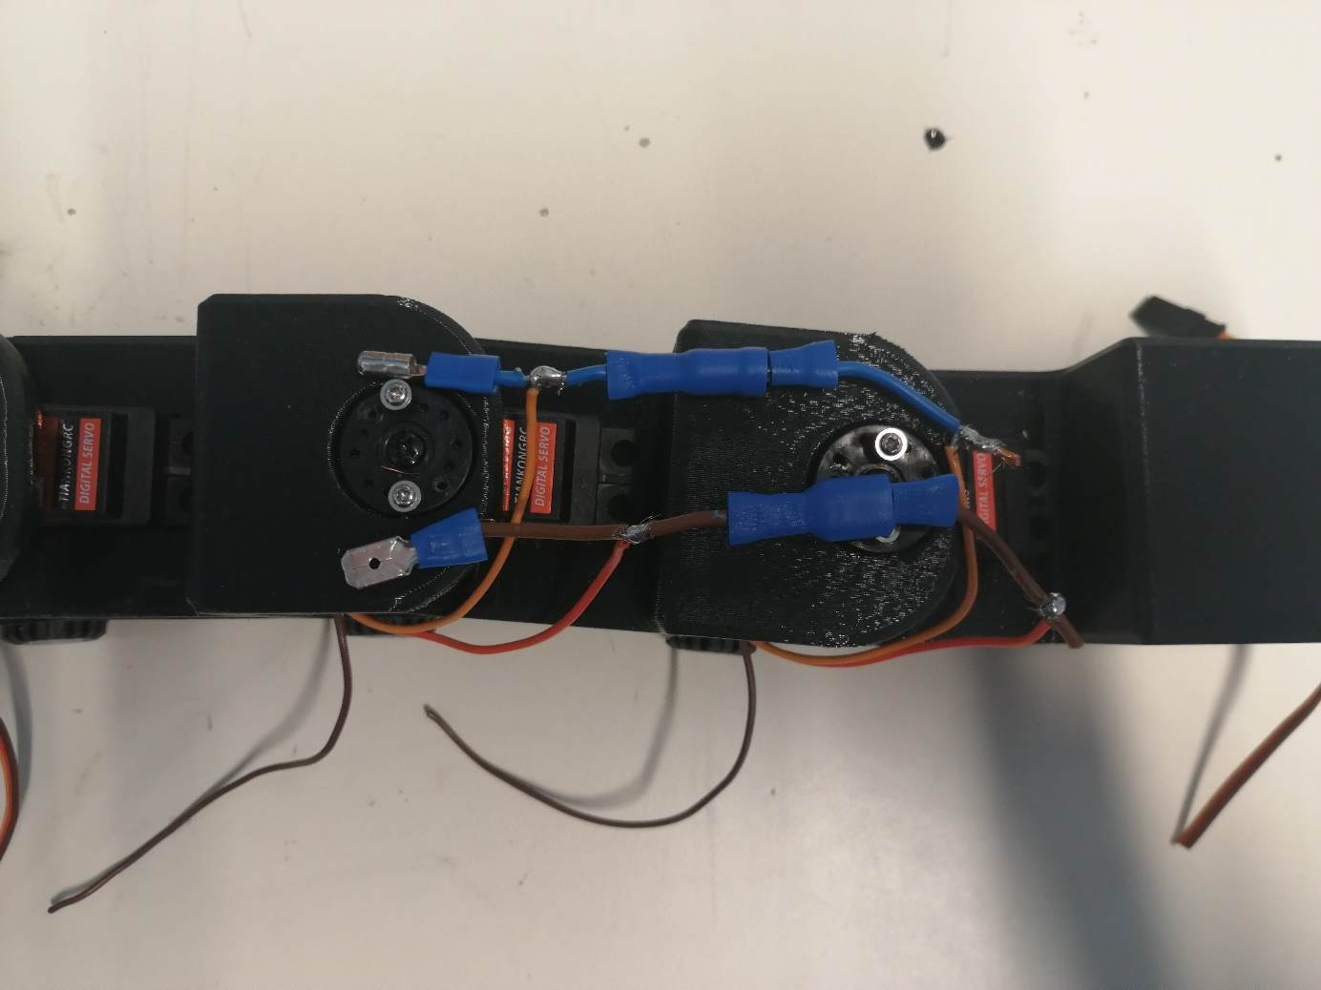

Figure 19.3.1

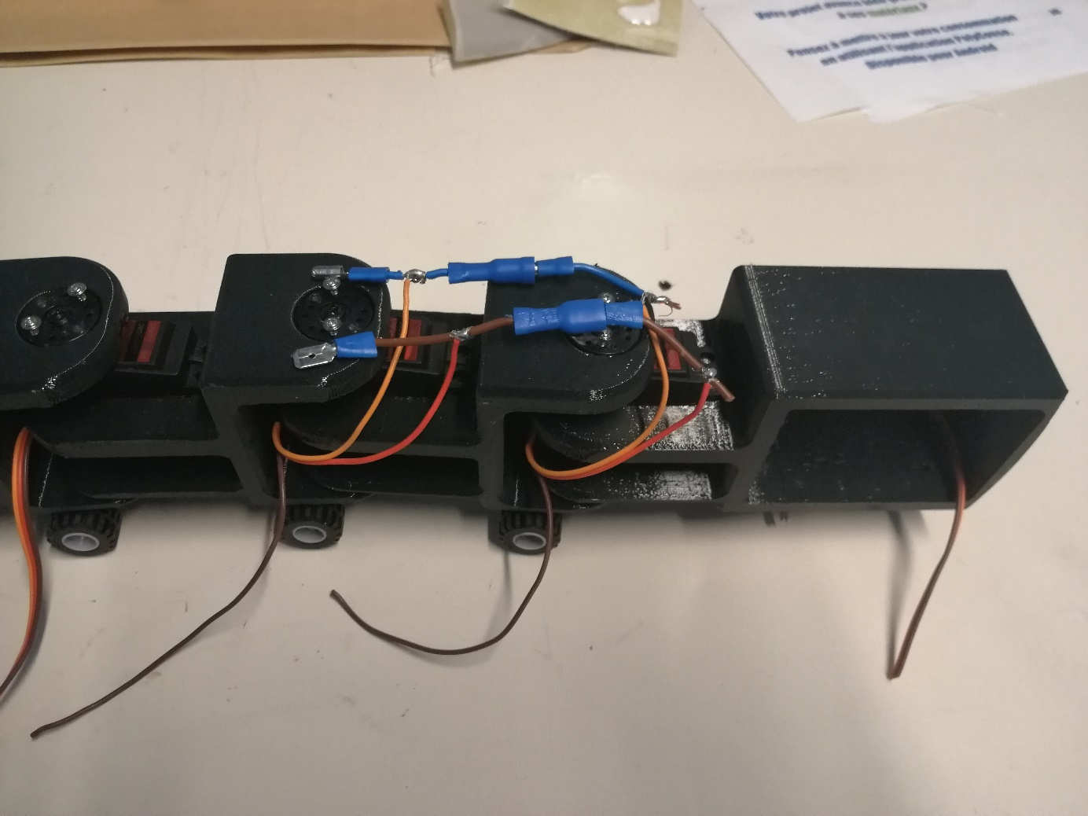

Figure 19.3.2

The rest of the connections will be made during the next session.